CRUD OPERATIONS
Seller and Inventory Management System
1. Aim
To perform CRUD operations on the Seller and Inventory tables using SQL commands.
2. Introduction
CRUD stands for Create, Read, Update, and Delete. These are the four basic operations used to manage records in a database.
In this project, CRUD operations are performed on the Seller and Inventory tables to add, display, modify, and remove records.
3. Types of CRUD Operations
3.1 Create
The Create operation is used to insert new records into the database.
In this project, a new seller can be added to the Seller table, and a new inventory record can be added to the Inventory table.
SQL command used: INSERT
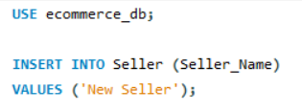
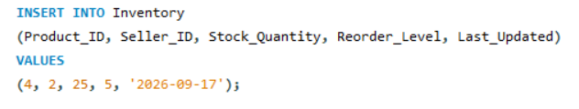

3.2 Read
The Read operation is used to retrieve and display existing records from the database.
In this project, seller details and inventory records can be displayed using SELECT statements.
SQL command used: SELECT
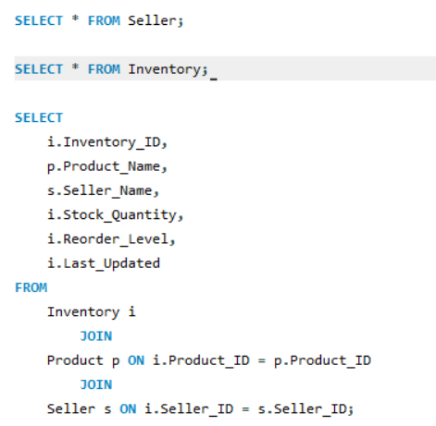

3.3 Update
The Update operation is used to modify existing records.
In this project, the stock quantity and reorder level of a product can be updated in the Inventory table.
SQL command used: UPDATE
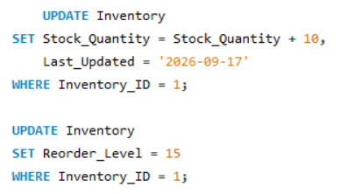

3.4 Delete
The Delete operation is used to remove unwanted records from the database.
In this project, an inventory record can be deleted using its Inventory_ID.
SQL command used: DELETE
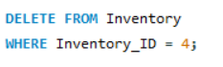

4. Importance of CRUD Operations
- Helps to manage seller information.
- Allows new inventory records to be added.
- Helps to display available stock details.
- Allows stock quantities to be updated.
- Removes unwanted inventory records.

5. Result
Thus, CRUD operations were performed successfully on the Seller and Inventory tables using SQL commands. These operations help to manage seller information and inventory records efficiently.

